|  |
| --- |
| **National University of Computer and Emerging Sciences** |
| In Lab Exercise 7  “Views, Stored Procedures” |
|  |
| Database Systems Lab |
| Spring 2021 |

Department of Computer Science

FAST-NU, Lahore, Pakistan

# Exercise

For this exercise use the following schema, the script to create this schema and populate data is given in ATM.SQL file

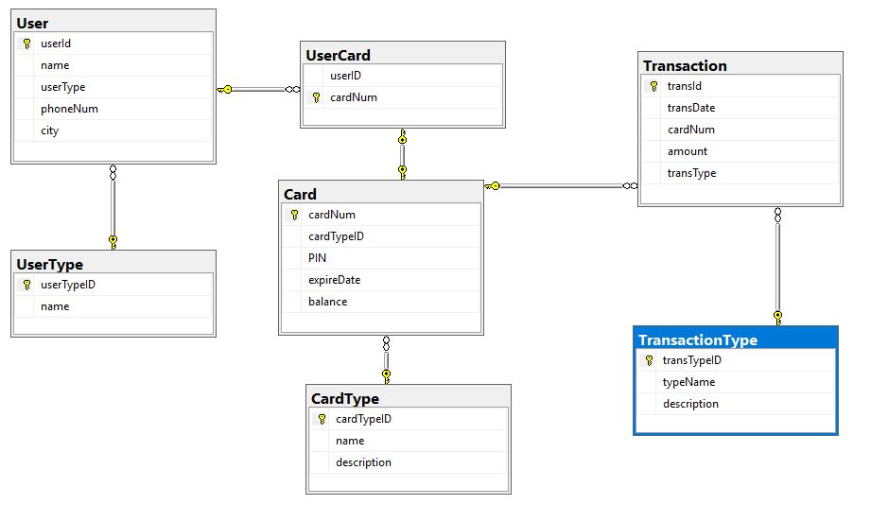

**Write a script to execute PROCEDURE for each question.**

1. Create a view to display all the details of each user.
2. Create a view that displays the **name, phone number, city, and cardNum** of each user who owns ATM card.
3. Create a procedure that takes the user's name and displays his details.
4. Create a procedure that returns minimum balance in an output parameter.
5. Create a procedure that takes user name, id and returns no. of cards of that user in an output parameter.
6. Create a procedure Login that takes card number, PIN, and returns the status in an output parameter. If card number and PIN are valid then @status =1 else @status=0.

(Hint: IF/ELSE).

1. Create a procedure to update the PIN. The procedure takes Card Number, old PIN, and new Valid PIN (Length 4) and prints ‘Updated PIN’ if PIN gets updated or ‘Error’ otherwise.

**(Google it if you don’t know how to compare the Length)**.

1. Create a procedure **WithDraw** using Login Procedure (Question#6), the procedure will take the Card Number, PIN, and amount for the transaction. Now insert detail of the transaction in **Transaction Table** if the transaction is successful with **TransType** =1(successful Transaction) and next **transID (calculate the max transID and increment transID, then insert in table).** If the transaction fails insert **TransType**=4 (Failed Transaction). Update the balance against the card number accordingly.